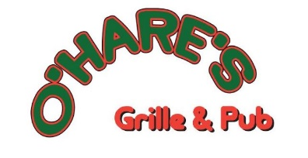
Time________
Date________
Employment Application
Pay________

In compliance with Federal and State equal employment opportunity laws, it is this company's intention to consider all qualified applicants without regard to race, color, religion, sex, national origin, age, marital status, disability, or the presence of non-job related medical conditions.

(PLEASE PRINT CLEARLY) Today's Date

Application for position as _

Name Phone # (Home) (Cell)_
First Middle Last

Address City State Zip

Date able to Start Pay expected Referral Source _
(Advertising, Employee, Walk-in, etc)
Will you work any shift? Yes No (Circle One) Full time Part time (Circle One)

List below any days and hours you will be available to work:

Sunday |  |  | Thursday
Monday |  |  | Friday
Tuesday |  |  | Saturday
Wednesday
================================================================================================
Employment Experience (start with most recent):

- Name of Company _City, State Dates of employment

Name of Supervisor Phone # ( )

Job Title Duties

Reason for leaving

- Name of Company _City, State Dates of employment

Name of Supervisor Phone # ( )

Job Title Duties

Reason for leaving

- Name of Company _City, State Dates of employment

Name of Supervisor Phone # ( )

Job Title Duties

Reason for leaving
EDUCATION:

High school attended Did you graduate? Yes No College attended Number of years completed
Major/Minor Did you graduate? Yes No

In addition to the work experience described in this application, what other experiences, skills or abilities do you have that should be considered in evaluating your qualifications for this job?

=========================================================================================== GENERAL INFORMATION:
Are you under the age of 18? Yes No (Circle one)

Why do you want to work for O’Hare’s Grille & Pub?

===========================================================================================
Please read the following carefully and sign below
I declare that I am qualified to perform all the duties of the position I am seeking. I also declare that the information I have provided on this application is correct and that any false statements or omissions will justify my rejection or dismissal. I authorize the company to contact any of my previous employers as well as any reference source to verify the facts and information in good faith. I will agree to a drug test, if permitted by law, to be paid for by the company.
Should I become involved in a claim for worker's compensation or any other litigation after employment by the company, I will allow the company to supply my employment records to an opposing party. If employed by the company, I understand that I will be an employee at will and that my employment with
O’Hare’s Grille & Pub may be terminated at anytime by myself or O’Hare’s Grille & Pub for any reason whatsoever. I further understand that if employed by O’Hare’s Grille & Pub, the owners alone have the authority to modify or change my status as an employee at will and that any such modification must be in writing signed by the Owner. Finally, I understand that this is only an application for employment and neither an offer of or a contract of employment and no part of this application shall be construed as an offer of employment or an employment contract.

Date Signature of Applicant

